THE BENSINGTON SOCIETY
December Meeting - Visitors Welcome
7 for 7.30 pm, Friday 26th January 2024, Benson Parish Hall
Non-Members Entrance Fee £5
Supper £5 - Bar Available

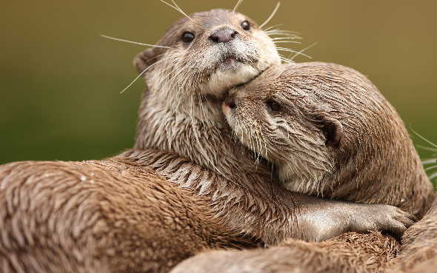
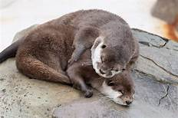

A LOT ABOUT OTTERS!

Since the Autumn of 2022, traces of otters have been seen in Benson Brook, and they are currently being studied by Benson Resident, Gavin McLauchlan. He will be talking about otters in general, their habits, habitats and behaviours and how their presence and movement in Benson is captured.
SPEAKER
Gavin McLauchlan

Gavin has been a resident of Benson for about 14 years, He is involved in many village activities, from being a Benson Parish Councillor, creating the Benson Allotment Association, through to giving talks on crayfish and otters. He is a very keen photographer, sportsman and gardener. His career has mostly been in TV Technology (he launched Freeview and BT TV) and data.

