BENSINGTON SOCIETY
Visit to Fawley Museum - 25th of June 2023
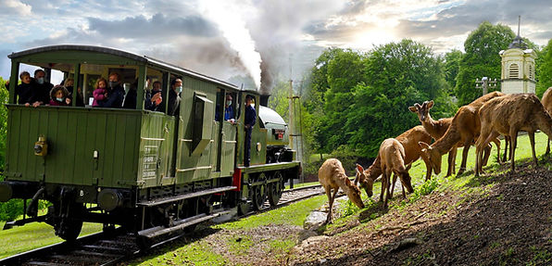
Fawley Museum is a private museum established in the 1960s by the late Sir William McAlpine at his estate near Henley on Thames. It hosts a fine collection of memorabilia and models relating to railways together with a working standard gauge railway. The museum and railway are open on a limited number of days per year and admission is only by prior application and invitation. Capacity is limited and tickets are not available on the day.

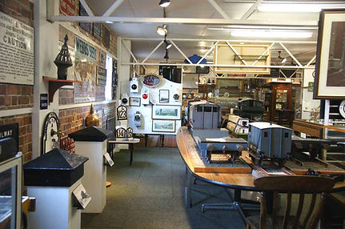
Fawley Museum has one of the largest collections of small railway artefacts in the country, displayed so as to enable visitors to appreciate the beauty and historic interest of each piece.
Railways made huge changes to the daily lives of working people. This is reflected in the wide variety of objects on display, such as enamel signs advertising products that could be sold across the country instead of just locally, posters advertising alluring holiday locations across Britain and maps of where the railway traveller could go. There is a display of objects associated with the British Empire Exhibition 1924-1925, many of which look remarkably modern nearly 100 years later. Another section is dedicated to the locomotive Flying Scotsman, saved for the nation by Sir William McAlpine, the Museum’s founder.

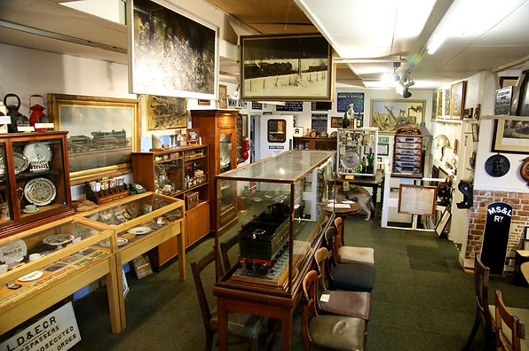
For the young at heart there are models of all sizes, from the huge to the tiny, from the brilliantly accurate to paperweight lumps. Above all, the Museum brings out the nostalgia of a lost age. A cry often heard inside the Museum is “I remember those!” We have limited the photographs of the Museum contents on this site, and we have to impose a strict "No Photography" rule on visitors inside the Museum. Do come and enjoy the huge variety of artefacts, but please take home memories, not surreptitious photographs.
