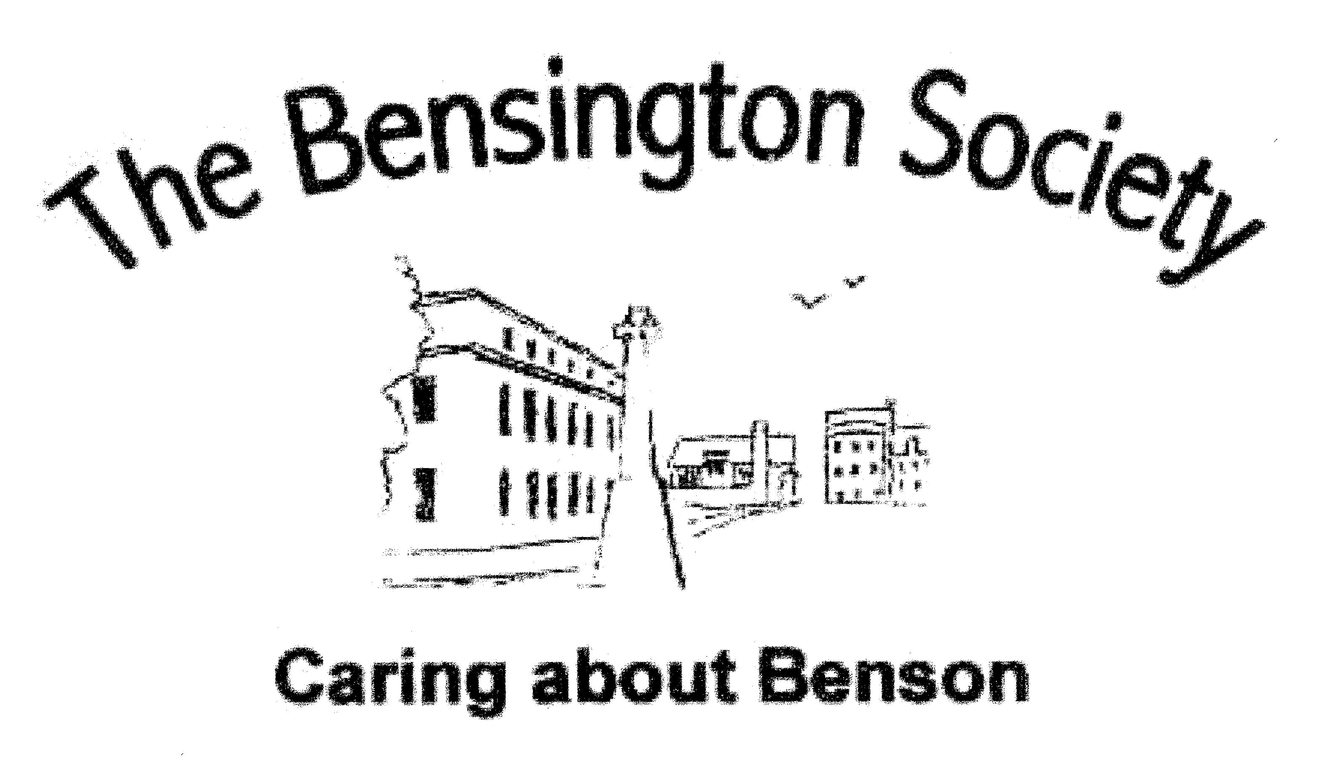

ANNUAL GENERAL MEETING 2022

CALLING NOTICE FOR ANNUAL GENERAL MEETING

Notice is given that the Annual General Meeting of The Bensington Society, hereafter referred to as The Society, will be held at 7pm on Friday 24th February 2023 in the Benson Parish Hall. The Agenda for the Meeting is below.

AGENDA

Note: All documents referred to are attached.

- To receive apologies

- To approve the minutes of the AGM held on 25th March 2022.

- To receive and note the Annual Report.

- To receive and approve the Balance Sheet and the Summary of Income and Expenditure for the year 2022:

- To formally thank Heather Emerson, the Independent Examiner for 2022, and to approve Heather Emerson as Independent Examiner for 2023.

- To elect/re-elect the members named below to the Committee for 2023.

- To elect a Vice President

- To approve the changes to the Constitution of the Society

- For ‘Dissolution of the Society’, listed below (Annex B).
- For ‘Data Protection and Cyber Security’, listed below (Annex B)

- To approve Charity Donations from the raffle profits

- Any Other Business

Annex A: Voting Return - Annual General Meeting 2023.
Annex B: Proposed Changes to the Constitution.

ELECTION OF VICE PRESIDENT, OFFICERS AND COMMITIEE MEMBERS
The Committee is comprised of Officers and Members in accordance with the Constitution. Terms of Reference for all the Committee positions are shown in the Rule Book, available in the Benson Library or on the Society’s web site www.bensington-society.com
We have a proposal to appoint an Honorary Vice President. This position is normally filled by a member who has given many years of service to the Society. This year the Committee proposes that David McGill, our immediate past Chairman be elected. David has successfully steered the Society through COVID, initiated many improvements as Chairman and brokered an agreement with the Benson Parish Council for the storage of archived records.

Current Committee Seeking Re-election

Chairman David McGill Elected by 2023 committee
Secretary Vacant Vacant
Treasurer Richard Peters, Richard Peters
Membership Secretary John Tchighianoff John Tchighianoff
Talks Fenella Galpin Fenella Galpin
Catering Coordinator Barbara Verdon Barbara Verdon
Planning Martyn Spence Martyn Spence
Bar Sue Cooper Sue Cooper
History Group Sue Brown Sue Brown
Publicity Vacant Vacant
H&S/Fire Peter Eldridge (co-opted member) Appointment deleted
Security Manager New appointment Peter Eldridge

Members wishing to nominate members for the position of Honorary Vice President, and the posts of Officer or Member of the Committee, should complete the form at the end of this report and return it to the Acting Secretary, George Verdon, The Stables, 11A Castle Square, Benson, OX10 6SD no later than the 14th February 2023.

On behalf of the membership, the Committee’s sincere and grateful thanks go to the following members who have assisted the Society throughout 2022:
David and Sue Cooper [Bar], Tanya Ellis and the Benson Parish Office Team [General Assistance], Heather Emerson (Books), Barbara Verdon (Raffles), Liz McGill (Salads Coordinator), Salad Makers, John Johnson and John Tchighianoff (Mulled Wine), George Verdon (Website and IT). Martyn Spence and Pete Eldridge (AV systems).
MEMBERSHIP RENEWAL
The Committee have proposed that the membership fee for 2023 should remail at £12 for individual membership and £120 for life membership.
Should a member not have received a membership renewal form, please contact the Membership Secretary, John Tchighianoff by email at: john.tchighi@tiscali.co.uk.

ANNEX A
TO BENSINGTON SOCIETY
CALLING NOTICE

Bensington Society
Nomination Form For Honorary Vice President, Officer And Committee Member For 2023

I hereby nominate (name):

To stand for (position):

Nominated by (name):

Signature:

Seconded by (name):

Signature:

Signature of nominee: (nominated person must sign here)

Please return to the Acting Secretary, George Verdon, by email to: paddy@chezverdon.com or by post to: The Stables, 11A C
Castle Square, Benson, OX10 6SD.
ANNEX B
TO BENSINGTON SOCIETY
CALLING NOTICE

PROPOSED AMENDMENTS TO THE CONSTITUTION

Dissolution of the Society

- Delete: Paragraphs 74 and 75
- Insert: New paragraph

74. Should the Society not be re-established during the period it is in abeyance, the Trustees shall convene a meeting of former members, by press notice or other means, to determine the disposal of the assets, including funds, of the Society and, also, what is to be done with the Minutes and other Records of the Society.

Data Protection and Cyber Security

Amend heading to `DATA PROTECTION to DATA PROTECTION AND CYBER SECURITY

- Delete: Paragraph 65
- Insert new paragraphs below and renumber the remaining paragraphs

65. The Society shall comply with the information protection and cyber security requirements of General Data Protection Rules (GDPR) where they apply to the Society.

66. The Committee shall appoint a Security Manager, who may be a committee member, a supporting committee member, but not an Officer of the Society.

67. The Society shall maintain a Security Policy document.

